Website Additions, subtractions and changes

Changes:

- 1 Change/Remove from Drop down under solutions- Resources + Dealer Insights & Lead Source + AI Audit

- COMBINE Navigation (primary)
Current: ‘Industry Insights’, ‘Resources’ will be replaced with [what naming]?
  - Updated to: [need title/naming]
INDUSTRY INSIGHTS [22 pages] AND RESOURCES [5 pages] and
  - Flyout Container: have the same type layout as ‘Solutions’ where it expands to show all (22 ‘Insight’ and 5 ‘Resource’)
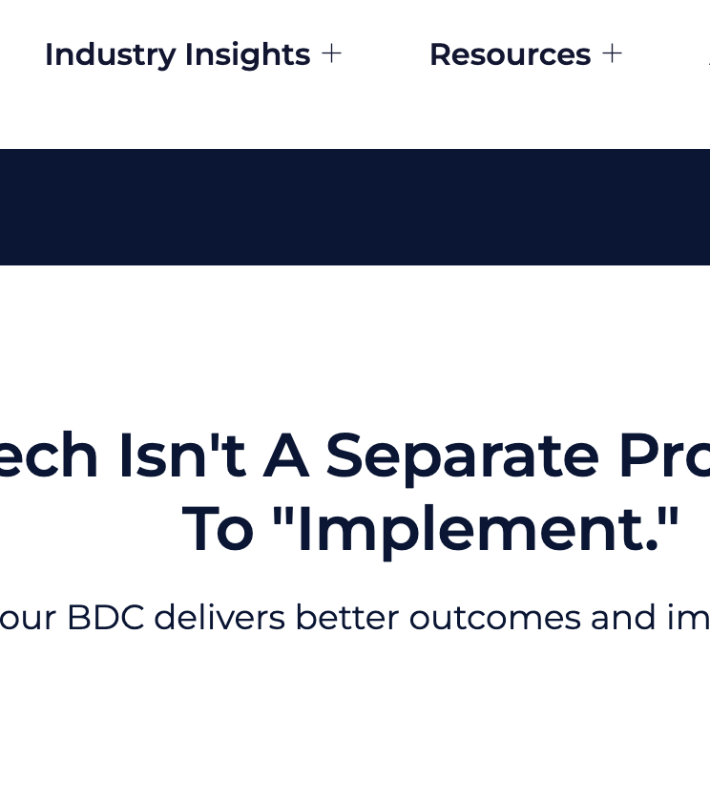

Like this
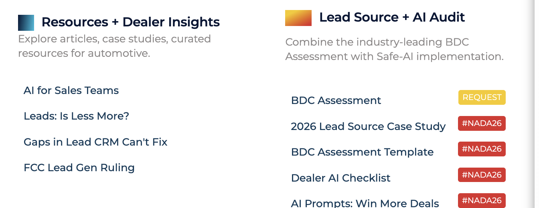

2 Change/Remove

Additions:

- 1 Add- To Industry insights tab with same disciple/layout when clicking on the plus under Industry insights. Have two headers. Resources + Dealer Insights & Lead Source + AI Audit

Then sort articles under each as they pertain to these headers.

Subtractions:

If you do the layout the way I suggested, there is no need to have navigation for both Industry sites and resources. Combine and make one navigation with a drop down of Resources + Dealer Insights & Lead Source + AI Audit

Additions: Please ADD- Also, each one of these can become a page at some point.
- FAQ makes it easy to quickly explain. Pages can get more detailed. https://docs.google.com/document/d/1eC_iwcBbj-STx5fSECZn9cCXPjbKM2NXOIToR4VGf7E/edit?tab=t.0

I did this for the 20 group site.
Add these

- FAQ
A. “How fast can we go live and what do you need from us?”
Most dealerships are live within two weeks.
We move quickly because onboarding is a defined, repeatable process: we confirm scope and hours, connect the required systems, align messaging and escalation rules, and train our team on your store. If you’re in a bind, we can often accelerate the timeline and launch faster with a phased rollout—then tighten and expand once you’re live.

B. “Which CRMs / DMS / chat tools do you integrate with?”
Strolid integrates with the major automotive CRMs and service scheduling platforms, so we can work inside the tools your team already uses.
We support the most common systems across dealer sales and service, and when a dealership uses something unique (or a new platform emerges), we can add integrations as needed—so your leads, appointments, notes, and outcomes stay connected and reportable.

C. “What channels do you cover?”
We cover Inbound/outbound calls, SMS, email, chat, Facebook/IG, OEM leads, service BDC leads and more.
D. “How do you handle compliance, recording consent, and data security?”
How do you handle compliance, recording consent, and data security?
Strolid is built to help dealerships communicate with customers in a way that’s auditable, permission-aware, and secure.
Recording + consent: We support consent-aware workflows so recording and message handling follow the rules that apply to your state(s) and channels. Where required, customers are notified and consent is captured before recording or continuing. We can also honor opt-outs and suppression lists to prevent unwanted outreach.
Policy-driven data handling: We treat customer conversations as sensitive data. Access is role-based, activity is logged, and we apply retention rules aligned to your dealership/group policy. When needed, we can redact or restrict sensitive fields (for example, payment details) and control who can view or export data.
Security controls: Data is protected in transit and at rest using industry-standard encryption. We use least-privilege access, secure credential handling, and monitoring to reduce risk and support incident response.
Transparency + auditability: Every interaction is visible in the Strolid Portal, so managers can review what was said, when it was said, and how it was handled—across calls, texts, email, and chat. That makes coaching easier and helps with compliance reviews.
Dealer-specific requirements: Compliance isn’t one-size-fits-all. We align workflows to your store’s policies (hours, escalation rules, disclaimers, do-not-contact rules, and any OEM/group requirements) and document how those rules are enforced.
E. “Who owns the conversation data?”
The dealership owns its customer conversation data.
Strolid captures and organizes calls, texts, emails, and chats so you can search, review, and report on them in the Strolid Portal. We act as a processor/service provider—meaning we handle the data to deliver the service, but we don’t claim ownership of your customer relationships or conversation content.
- Your data stays yours: You retain ownership of conversation records and the insights derived from your operations.
- Portability: You can export or retrieve your conversation history and reporting as needed (subject to retention settings and legal requirements).
- Controlled access: You decide who can view, manage, and export data via role-based permissions.
- Protected use: Strolid uses the data only to provide and improve the service under your agreement, with safeguards around privacy, security, and confidentiality.
F. “How do you measure ROI and what KPIs will I see?”
We measure ROI—and then we show you the why behind it.
Strolid tracks the KPIs that move metal and grow service: response time, contact rate, appointments set, shows, sold, and service RO volume. But we don’t stop at the numbers. We tie your leads + calls + texts + emails + chat into one conversation record, then break performance down by new/used, inventory, lead source, store/group, and process compliance.
On top of that, Strolid GPT pulls “signals” out of real customer conversations—price objections, trade intent, payment questions, urgency, complaints—so you can see what’s happening right now and fix it before it costs you sales. .
In short: Strolid doesn’t just help you work faster. It helps you run tighter, follow up better, and make better decisions, so profitability goes up.

G. “How do you train your agents on our store?”
Training is at our core—but we don’t rely on training alone.
Every store has a lot to remember: hours, departments, specials, inventory realities, service policies, pricing boundaries, escalation rules, and “how you want to sound.” So we do two things:
- Store-specific onboarding: We train agents on your brand voice, processes, hours, offers, and escalation rules so they represent your dealership like an extension of your team—not a generic call center.
- Real-time guidance through our AI Dialer: When a customer engages, our agents have your most important sales and service information on-screen—along with Strolid GPT insights and conversation history. This reduces guesswork and keeps answers consistent.
- Human + AI co-pilot (coming soon): Our agent co-pilot will guide agents through each conversation in real time—prompting the right questions, next steps, and handoffs—so process stays tight even when conversations get emotional or complex.
The result: agents who sound like your store, follow your rules, and have the information they need in the moment—without relying on memory or perfect notes.

H. “What does pricing look like?”
Strolid pricing is a flat monthly fee based on the volume of conversations and workload you want us to handle, so you get predictable costs even when the business is seasonal.
- Service BDC starts at $499/month and scales with RO/customer contact volume and scope.
- Sales BDC / 24-7 lead response + chat starts at $599/month and scales with lead and call volume.
To quote accurately, we review your last 6 months of lead and call activity, confirm coverage (hours/channels), and define scope. Then we deliver a clear proposal with what’s included, expectations, and the KPIs we’ll be accountable to.

Please replace this page of content with:
- https://strolidstg2.wpenginepowered.com/ai-tools-for-auto-dealer/

Delete this page:
- https://strolidstg2.wpenginepowered.com/chasing-vs-focusing-on-current-leads-what-should-you-do/

I like easy quick to read content that says what we do.

- With:
AI Tools for Car Dealers

Strong Process. Solid Results.
Real people that help you sell more cars with AI behind it.
Strolid combines trained BDC specialists + AI so every lead gets answered fast, every conversation is captured, and follow-up stops falling apart.
Request Your Free BDC Assessment → (button)

Dealers don’t need more “AI.” They need better follow-up.
Most dealerships aren’t losing deals because of inventory or pricing. They’re losing deals because of:
- slow response times
- missed calls / missed texts
- weak notes and CRM blind spots
- inconsistent follow-up
- turnover and coverage gaps
- Teamwork between our team and yours
- Connect your customers with trust and empathy.
Your CRM isn’t broken. Your follow-up is.
Strolid fixes it.

What Strolid’s AI tools actually do (in dealer terms)
1) Instant response across every channel
Calls, texts, email, chat, and social, customers get a fast, consistent reply, every time.
2) Human escalation when it matters
AI can answer questions. Humans make promises, pricing, trade, credit, availability, and emotional situations get handled by a real person immediately.
3) Conversation intelligence you can coach from
Your CRM shows notes. Strolid shows the actual conversation.
Search calls/texts/emails/chats and see:
- what customers asked
- what objections came up
- what caused missed appointments
- where process breaks across rooftops
4) Scale without the staffing rollercoaster
More volume shouldn’t mean more chaos. We absorb spikes without you hiring, training, and replacing people every quarter.

Built for auto reality: speed, process, accountability
We measure what moves metal (and grows service):
- response time
- contact rate
- appointments set / show / sold
- service RO volume (when applicable)
- Hot leads
- Lead quality
And we break it down by what dealers care about:
- new vs used
- lead source
- rooftop / group
- conversation “signals” (price objections, trade intent, payment questions, urgency, complaints)

How fast can we launch?
Most dealers live within two weeks.
If you’re in a bind, we can accelerate with a phased rollout and tighten the process once you’re live.

Want to know if you’re leaking deals?
If any of these are shaky, you’re losing sales you already paid for:
- Speed to lead: are you consistently responding in minutes—not hours?
- Coverage: do old leads get worked or forgotten?
- Visibility: can you see what was said or just notes?
- Scalability: does performance drop when volume spikes or staff changes?
Request Your Free BDC Assessment →
We’ll show you where the leaks are and what it’s costing you.

Vin’s Quote:
“Your CRM didn’t ghost your leads. Your process did.”
Vin Micciche

- Apply **SEO Polish**

# Optional: **SEO Polish** (without sounding “AI-ish”)

If you want this page to rank for the title term, do one of these (not all):

>* Use “AI tools for car dealers” in the H1 (you already are)

>* Use it once in the first paragraph

Use a few natural related phrases in headings:
>* “lead response”
>* “BDC”
>* “appointment setting”
>* “conversation intelligence”
>* “service scheduling”
>* “dealer group reporting”
---
## Meta Title + Description (ready to paste)
**Meta Title:**
AI Tools for Car Dealers | Strolid BDC + AI Co-Pilot
**Meta Description:**
Strolid combines trained BDC specialists with AI to improve speed-to-lead, appointment set/show/sold, and conversation visibility across calls, texts, email, and chat. Free BDC assessment.
---


- Please replace this page with: https://strolidstg2.wpenginepowered.com/chasing-vs-focusing-on-current-leads-what-should-you-do/

New Page

STRONG PROCESS. SOLID RESULTS.

Key Gaps in Lead Management for Auto Dealers

Your CRM isn’t broken. Your follow-up is.
CRMs are great at storing leads. They’re terrible at making sure anyone works them.
If you’re like most stores, the gap isn’t “more technology.” It’s this:
- leads hit the CRM
- response is delayed
- follow-up gets inconsistent
- notes get thin (or fictional)
- managers can’t see what was actually said
- the customer buys somewhere else
Strolid closes those gaps with speed, accountability, and conversation visibility—without replacing your team.
Request Your Free BDC Assessment → (CTA button)

The 5 lead leaks your CRM won’t fix

1) Speed-to-lead (minutes matter)
If you’re not responding fast across calls, texts, email, chat, and social, you’re donating deals.

2) Inconsistent follow-up
CRMs don’t enforce effort. People do. When the showroom gets busy, follow-up is the first thing to slip.

3) “Notes” instead of truth
A note is an opinion. A conversation is a fact. If you can’t pull up what was actually said, you can’t coach or fix outcomes. We push conversation summaries right into your CRM.

4) No visibility across channels
Customers bounce between phone, text, email, chat, and social. Most stores can’t see the full thread in one place.

5) Scalability (the staffing rollercoaster)
More leads shouldn’t require more chaos. Turnover, coverage gaps, and training cycles destroy consistency.

What Strolid adds to your CRM
We don’t replace your CRM. We make it work.
- 24/7 response + consistent follow-up (sales and service)
- Human + AI engagement with a real “escape hatch” when it matters
- Every conversation captured and searchable in the Strolid Portal
- Dealership KPIs that actually move metal: response time, contact rate, appt set/show/sold, service RO volume
- Conversation signals (price objections, trade intent, payment questions, urgency, complaints) so you can fix the real blockers
Request Your Free BDC Assessment → (CTA button)

A better (sharper) Vin quote for the bottom
“We don’t ask your team to work harder. We make the process tighter.”
Vin Micciche

